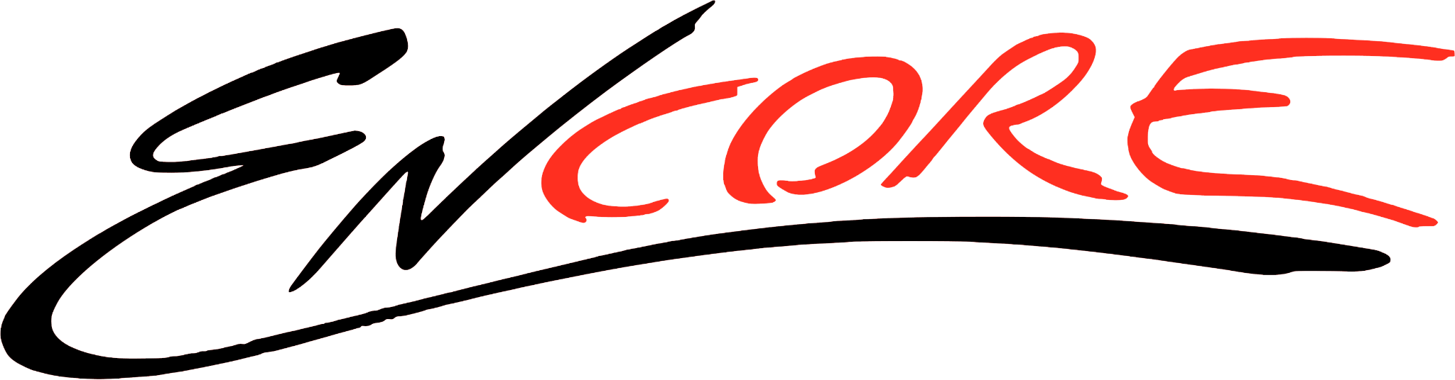

Summer Camp Registration Form

Name:_______________________________________________

Parent/Guardian Name:________________________________________

Address:_____________________________________________________

_____________________________________________________________

Contact #:______________________________

Email:__________________________________

** Announcements & important reminders will be sent via email only**

Age of Dancer:__________

Food Allergies:__________________________

How did you hear about us?_______________________________________

**All camps require a non refundable deposit of $100 when registering. Remainder of camp balance ($150) will be auto drafted one week prior to camp start date. Camps are subject to cancellation if there are not enough spots filled. Camp fee includes a $50 yearly registration fee. Deposit can be paid by cash, check, draft or venmo. Venmo: Sarah-Phillips-22**

Please check which summer camp you are registering for:

_____ Ballerina Princess Camp- Ages 2-6- June 9th-13th- 9:00-12:00- Camp Fee $250

_____ Ballerina Princess Camp- Ages 2-6- July 21st-25th- 9:00-12:00- Camp Fee $250

_____ Tumble Tots- Ages 3-7- June 9th-13th- 9:00-12:00- Camp Fee $250

_____ Tumble Tots- Ages 3-7- June 23rd-27th- 9:00-12:00- Camp Fee $250

_____ Tumble Tots -Ages 3-7- July 21st-25th- 9:00-12:00- Camp Fee $250

_____ Broadway Dance Camp- Ages 4-7- June 23rd-27th- 9:00-12:00- Camp Fee $250

Please read and sign waiver of liability:

I, (parent or guardian’s name), hereby give my child,

(dancer’s name), permission to dance with Encore/all staff at Encore Dance Studio for the year 2024-2025. I waive the right to any legal action against Sarah Phillips, Encore, or any other staff at Encore Dance Studio for any injury sustained on their property or at any event. I understand that I am enrolling my child in a program of physical activity and have agreed that my dancer is in good physical condition and does not suffer from any disability that would prevent or limit participation in this dance program.

Signature:______________________ Date:_________________________

I give Encore Dance Studio/ Sarah Phillips my approval to use photo or video footage of my dancer in class. Initial here: _______