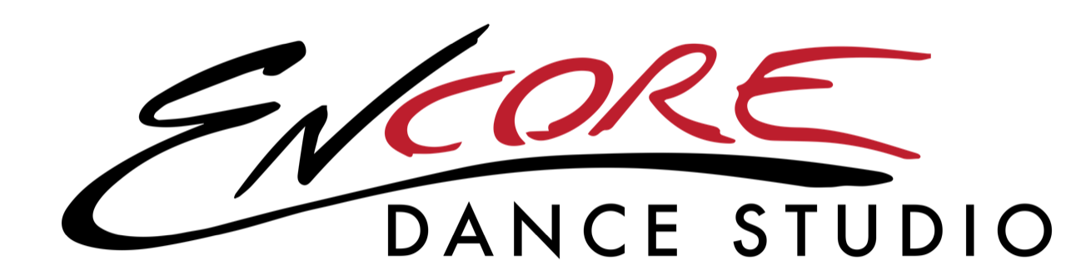

Summer Dance Session Registration Form

(email registration form & draft form to encoredance22@gmail.com)

Name:_______________________________________________

Parent/Guardian Name:________________________________________

Address:_____________________________________________________

_____________________________________________________________

Contact #:______________________________

Email:__________________________________

**This is how Encore contacts parents on announcements & important reminders, please list correct email address.

Age of Dancer:__________

Food Allergies:__________________________

How did you hear about us?_______________________________________

**Encore yearly registration fee of $50 is due when registering.**

(Venmo, Cash, Check or Draft. Checks payable to Encore - Venmo Sarah-Phillips-22)

Please check which summer session class you are registering for:

_____ Tuesday- 5:00-5:45- Ballet & Tap- Ages 2-4

_____ Tuesday- 5:45-6:30- Ballet & Tap- Ages 5-8

_____ Wednesday- 5:00-5:45- Mini Hop- Ages 4-7

_____ Wednesday- 5:45-6:30- Jazz & Tap- Ages 5-8

_____ Wednesday- 6:30-7:30- 6th-7th Grade Dance Technique/Prep Class

*Summer session monthly fees are auto draft only, $75 due on June 1st & July 1st.

Please fill out the summer session draft form.*

Please read and sign waiver of liability:

I, (parent or guardian’s name), hereby give my child,

(dancer’s name), permission to dance with Encore/all staff at Encore Dance Studio for the year 2024-2025. I waive the right to any legal action against Sarah Phillips, Encore, or any other staff at Encore Dance Studio for any injury sustained on their property or at any event. I understand that I am enrolling my child in a program of physical activity and have agreed that my dancer is in good physical condition and does not suffer from any disability that would prevent or limit participation in this dance program.

Signature:______________________ Date:_________________________

I give Encore Dance Studio/ Sarah Phillips my approval to use photo or video footage of my dancer in class. Initial here: _______